INTRODUCTION
This document serves as the stakeholder engagement guide and communication framework for plan development, establishing engagement methods, identifying key stakeholder groups, and providing a high-level timeline to support coordination through plan completion.

REGULATORY REQUIREMENTS
The regional water supply plan must comply with 9VAC25-780, which establishes requirements for:
- Regional cooperation in water supply planning
- Technical content and analysis standards
- Public participation processes
- Coordination with state agencies
- Plan approval and implementation procedures
Much of this plan was derived from the Guidance Memo No. 25-2002 provided by DEQ. Please reference Administrative Code Chapter 780. Local and Regional Water Supply Planning and the guidance memo for specific regulatory requirements and roles.

ENGAGEMENT OBJECTIVES
Through the stakeholder engagement process outlined in this plan, RVARC hopes to achieve the following objectives:
- Develop a regionally relevant and implementable plan
- Plan informs State and other Local and Regional Water Supply Plans
- Ensure broad stakeholder representation throughout the planning process
- Facilitate transparent communication about water supply challenges and solutions
- Build consensus on regional water management strategies
- Incorporate diverse perspectives into plan development
- Meet all regulatory requirements for public participation

ENGAGEMENT STRATEGY AND METHODS
This section serves as the stakeholder communication framework for meeting required planning obligations, supporting planning objectives, and applying additional best practices through a tiered approach that begins with regulatory requirements and builds toward broader participation.

TIER 1: PUBLIC MEETINGS AND PUBLIC NOTICES (REQUIRED)
This section provides guidance on how to conduct the required public participation steps once the Regional Planning Unit (RPU) has completed a draft Plan. The RPU and/or the local governments must consider all public comments received and may revise the draft Plan to address the comments. For more information or details please see Guidance Memo No. 25-2002 provided by DEQ.

Public Notices - 9VAC25-780-55.A
Local government responsibilities: The regulation states that the draft regional water supply plan developed by the regional planning unit shall be publicly noticed once in a newspaper of general circulation in each county, city, and incorporated town in the regional planning area. A public notice in a newspaper of general circulation that covers multiple local governments within a regional planning area shall satisfy this requirement for each local government included within that area of general circulation.

Public Meetings - 9VAC25-780-55.B, C, and D
Local government responsibilities: Local governments must track requests for public informational meetings and communicate with the RPU if 15 or more individual requests are received. If a local government receives 15 or more requests for a public informational meeting, then that local government must issue a second notice announcing a public informational meeting that is held at least 15 days after the notice is published. During the public informational meeting, the local government must present a summary of the Plan and offer the public a reasonable opportunity to offer questions or comments on the Plan. The manner of receiving comments is at the discretion of the local government but may include a question-and-answer session, multiple stations with staff to answer questions, or other appropriate methods. The local government must accept comments for 15 days following the public informational meeting. The local government is encouraged to provide the notice of the public information meeting to the Department so that it can be posted on the Department’s website.
Regional planning unit responsibilities: RPUs may choose to help coordinate any jointly held public meetings. RPUs may choose to develop one public meeting presentation to be used throughout the region.

Public Comment - 9VAC25-780-55.E and F
Local government responsibilities: Local governments must send any comments received to all members of the RPU. Local governments given responsibility by the RPU to respond separately to comments must prepare a written summary and responses to comments, which is then provided to the RPU for inclusion in the Plan.
Regional planning unit responsibilities: The RPU determines the method of response to public comments received, and if the comments require edits to the draft Plan. The regulation allows for responses to comments to be prepared separately by each local government, or as a joint document of all comments received by local governments. The RPU must consider all comments received and may revise the Plan to address those comments. Comments must be compiled, and their responses included as an attachment to the final Plan (9VAC25-780-50.H.4). No further public notice is required if revisions are made to the Plan in response to comments received.

TIER 2: STEERING COMMITTEE
RVARC will develop and convene a steering committee to guide the plan’s development. The committee will be comprised of representatives from the local governments and waterworks responsible for the operation of the region’s water systems. Members of the steering committee will be expected to:
- Attend steering committee meetings that will be held at key points in the planning process,
- Act as the primary liaison between RVARC staff and the locality/agency they represent,
- Participate in locality-specific meetings as needed throughout the planning process, and
- Review completed drafts of plan sections related to their jurisdiction.
One primary and alternate representative from each local government and water authority are recommended to participate with the steering committee. Alternates are encouraged to attend meetings, be familiar with deliberations, and participate through the primary representative. Local governments and water authorities are requested to notify the Department or coordinating PDC of any change in their representative or alternates and provide updated contact information (name, title, affiliation, phone number, and email) within 30 days of the change.

TIER 3: WATER SYSTEMS AND WATER USERS COMMUNICATION PLAN
The regulation requires local governments to make reasonable efforts during Plan development to consult and coordinate with Community Water Systems (CWS) and Self-Supplied Users (SSU) that use more than 300,000 gallons in any month. Consulting and coordinating with these users are the primary means by which local governments or their third-party delegate can collect, verify, and update critical information on existing and future use to include in the Plan. Reasonable efforts to consult and coordinate with CWSs and SSUs may be demonstrated by making information requests and providing options for ongoing collaboration.
Proposed communication plan for SSUs and CWS as follows:

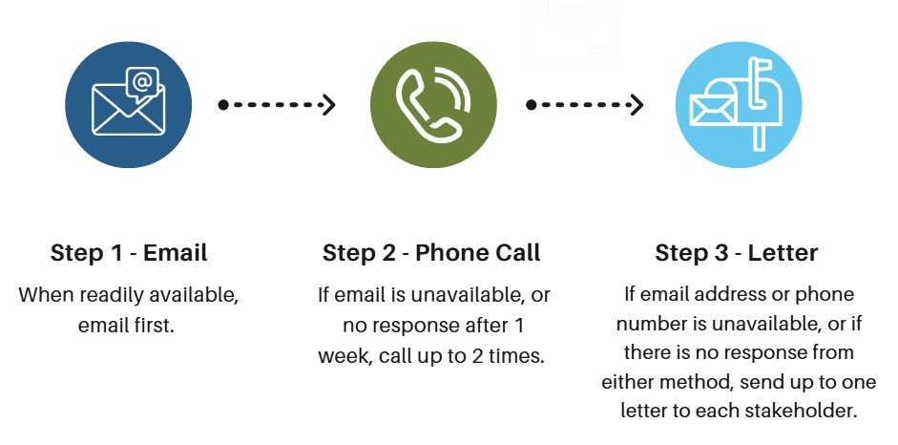

TIER 4: STAKEHOLDER ADVISORY GROUP
RVARC will engage with broader representation from business, agriculture, and community groups when additional technical support, data, or community input is needed. This may include but is not limited to environmental and citizen advocacy representatives, agricultural stakeholders, water resource engineers and planners, economic development specialists, academic and research institution participants, and legal and regulatory experts.

TIER 5: GENERAL PUBLIC EDUCATION
The engagement plan will include public education to raise community awareness, encourage meaningful input, and help ensure the regional water supply plan is informed, relevant, and responsive to local needs. Public engagement also supports transparency and helps identify community priorities early in the planning process.

Methods
Social Pinpoint Page - Access at engage.rvarc.org
Public survey – For plan guidance and engage public earlier in planning process
In person meetings at the locality level – Allows community members a face-to-face opportunity to learn about the plan
Other ideas include social media campaigns, advertise on locality websites, libraries, schools, county
fairs, farmers markets….

TIER 6: STATE AGENCY REVIEW & APPROVAL
Upon submission of the plan to the Virginia Department of Environmental Quality (DEQ), the Department will acknowledge receipt and provide a tentative review schedule, then circulate the plan to

partner state agencies for a 90-day review period. Following its initial compliance review, DEQ will issue tentative findings and identify any needed revisions, which the Regional Planning Unit and participating jurisdictions must address within the timeframe established by the Department. Once DEQ reaches a tentative compliance decision, the plan will proceed through a required 30-day public notice and comment period, and a public meeting may be held if needed before final action. After considering agency comments, local responses, and any public input, DEQ will forward the plan with its recommendation to the State Water Control Board for a final compliance determination. The plan should also acknowledge that DEQ may identify items for correction or refinement in future updates, with interim review expected every five years and full revision and resubmission required every ten years.

STAKEHOLDER IDENTIFICATION
RVARC staff have identified a range of potential stakeholders—at the local, regional, and state levels—to communicate the Water Supply Plan’s needs, milestones, and overall progress. This includes groups that influence water policy and funding, partners involved in implementation, and community voices that will be affected by long-term water supply decisions.
The regulation (9VAC25-780-30) defines "Stakeholder" as industrial and agricultural water users, public water authorities, private water suppliers, developers and economic development organizations, and conservation and environmental organizations.

Primary Stakeholders
Primary stakeholders are the entities with direct responsibility for developing, informing, and implementing the water supply plan, as they hold regulatory authority or provide essential local planning and water system information.

Planning District Commission
Roanoke Valley-Alleghany Regional Commission (RVARC)

Local Government Jurisdictions

City of Roanoke Roanoke County Bedford County
Franklin County
City of Salem Town of Vinton
Town of Rocky Mount

Water Utilities
Western Virginia Water Authority Bedford Water Authority

Secondary Stakeholders
Secondary stakeholders are organizations and subject-matter participants whose operational experience, technical knowledge, or sector-specific perspective can strengthen the plan by contributing informed input throughout the planning process.
To be continuously identified throughout planning process and may include stakeholders from the following sectors. Examples provided as placeholders.

Adjacent Planning District Commissions
West Piedmont PDC Central Shenandoah PDC Major Water Users
TBD

Industrial and Commercial
TBD

Colleges and Universities
TBD

Hospitals
TBD

Institutional
TBD

Agricultural Stakeholders
Farm Bureaus
Virginia Cooperative Extension Cattle and Dairy Farming Operations

Environmental and Conservation Organizations

Federal Stakeholders

New River Valley RC Central Virginia PDC

Irrigation associations and water user groups Soil and Water Conservation Districts

U.S. Environmental Protection Agency
U.S. Army Corps of Engineers
U.S. Geological Survey
Natural Resources Conservation Service USDA Rural Development
U.S. Forest Service
Virginia Department of Environmental Quality (DEQ)
Virginia Department of Health
Department of Conservation and Recreation Marine Resources Commission
Department of Historic Resources Department of Wildlife Resources
and other agencies deemed appropriate by DEQ

IMPLEMENTATION TIMELINE

Phase 1: Project Initiation Activities (Months 1-3, Fall 2025)
- Review “Resources for Plan Development” provided by DEQ
- Begin data collection using the 70-80-100 excel workbook provided by DEQ
- Convene kick-off meeting

Phase 2: Data Collection and Analysis Activities (Months 3-TBD, Spring 2026-TBD)
- Continuing to work with local governments, water authorities, and other municipally owned and operated water systems to fill data gaps determined in Phase 1
- Contact all large Self-Supplied Users (SSU) and Community Water Systems (CWS) to provide existing water sources, use, and demand data
- Estimate total self-supplied water use
- Confirm water purchases between water users and suppliers in the region
- Make “reasonable effort” to complete the 70-80-100 excel workbook to provide the U.S. Army Corps of Engineers with data needed to begin demand projections

Phase 3: Plan Development Activities (TBD)
- Drafting of the plan
- Coordination with U.S. Army Corps of Engineers
- Public education and engagement
- Stakeholder engagement through steering committee and other stakeholder groups
- Regional approval process facilitation

Phase 4: Final Deliverables (TBD)

- State agency review coordination
- Local government approval processes
- Plans to be submitted to DEQ by Oct. 9, 2029

