Marketing Toolkit: Craig County Septic Pump-Out Program
April 2026
8.5’ x 11’ Flyer available for download at https://engage.rvarc.org/septic

Social Media & Email Shareables
Option 1 Option 2
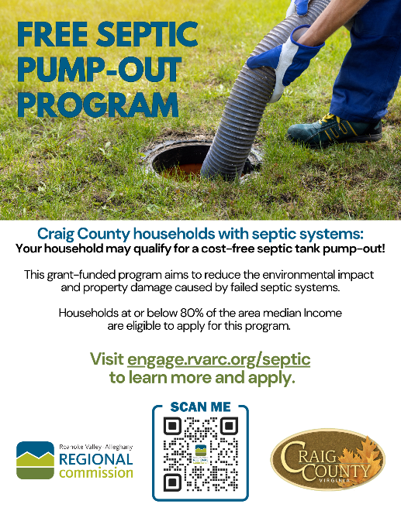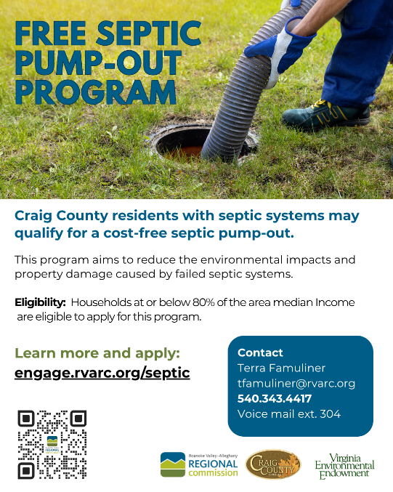
🏠Craig County residents with septic systems – your household may qualify for a FREE septic tank pump-out! 🚽
💧This program aims to reduce the environmental impacts and property damage caused by failed septic systems.
This grant program is through the Roanoke Valley-Alleghany Regional Commission in partnership with Craig County and the Virginia Environmental Endowment. Craig County households at or below 80% of the area median income are eligible to apply for this program.
✅ See eligibility details and apply now: https://engage.rvarc.org/septic
Questions? Contact Terra Famuliner at tfamuliner@rvarc.org or call 540-343-4417 ext. 304.

